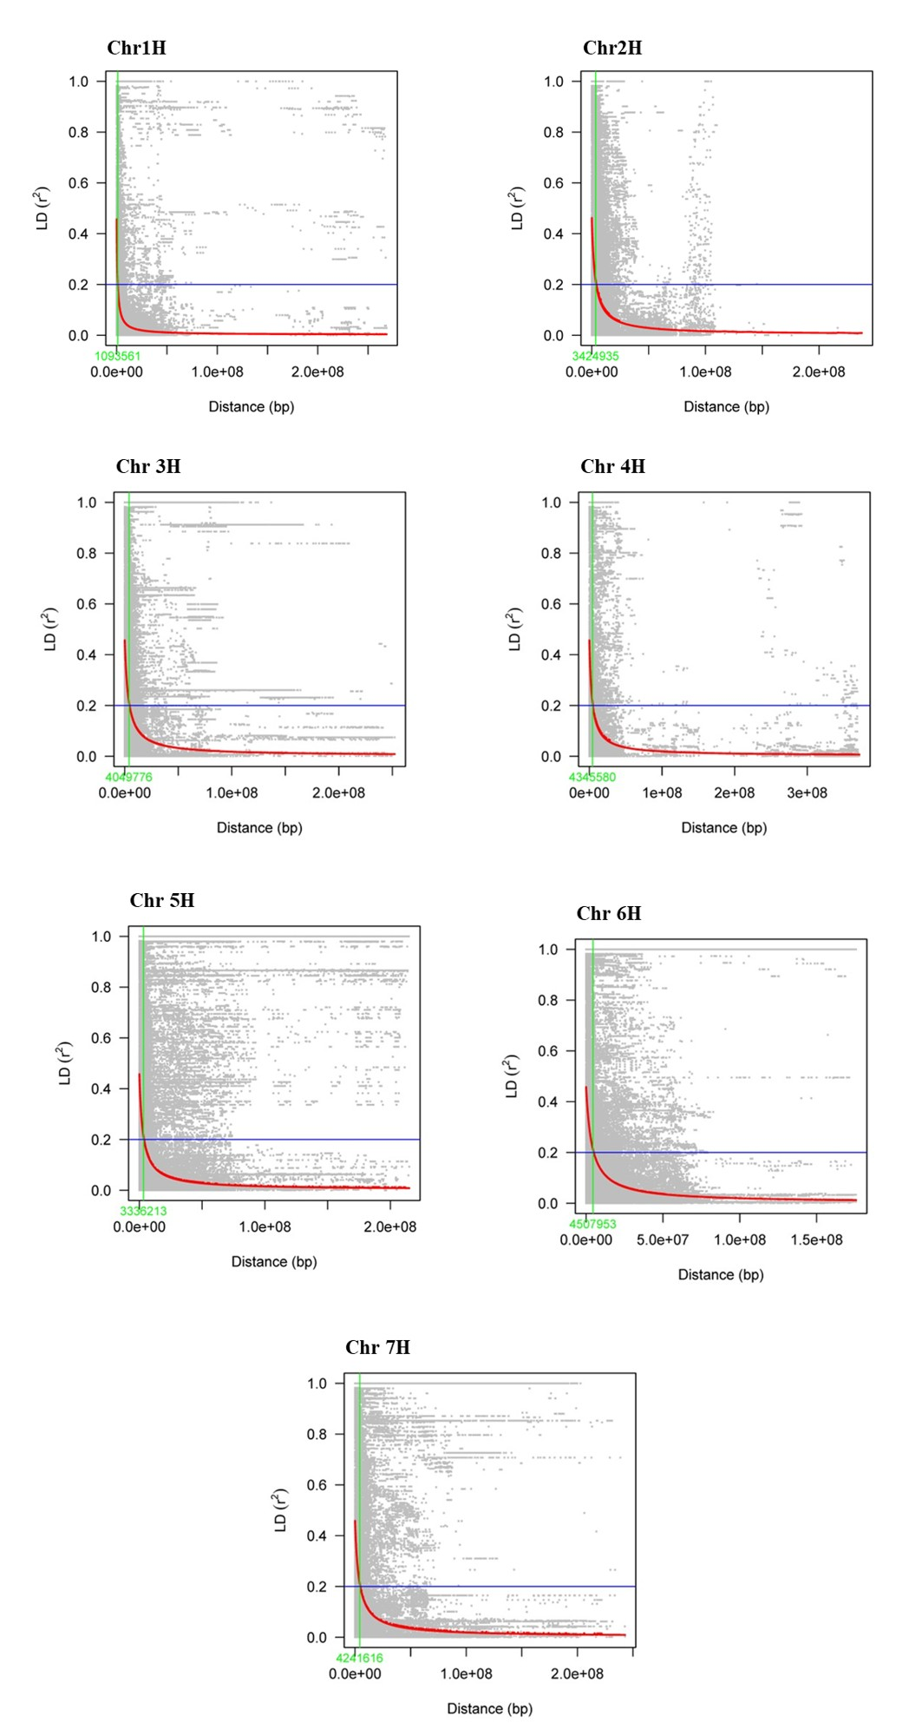
Supplementary Figure S1. Chromosome-wide LD decay plots fitted against the physical distance (i.e., base pairs) in two-row subpopulation. The blue horizontal line represents the half decay distance (r2). The red curved line represents the smooth regression model fitted to LD decay. The green vertical line represents the distance between the marker pairs which intersects the half decay and the LD decay curve.
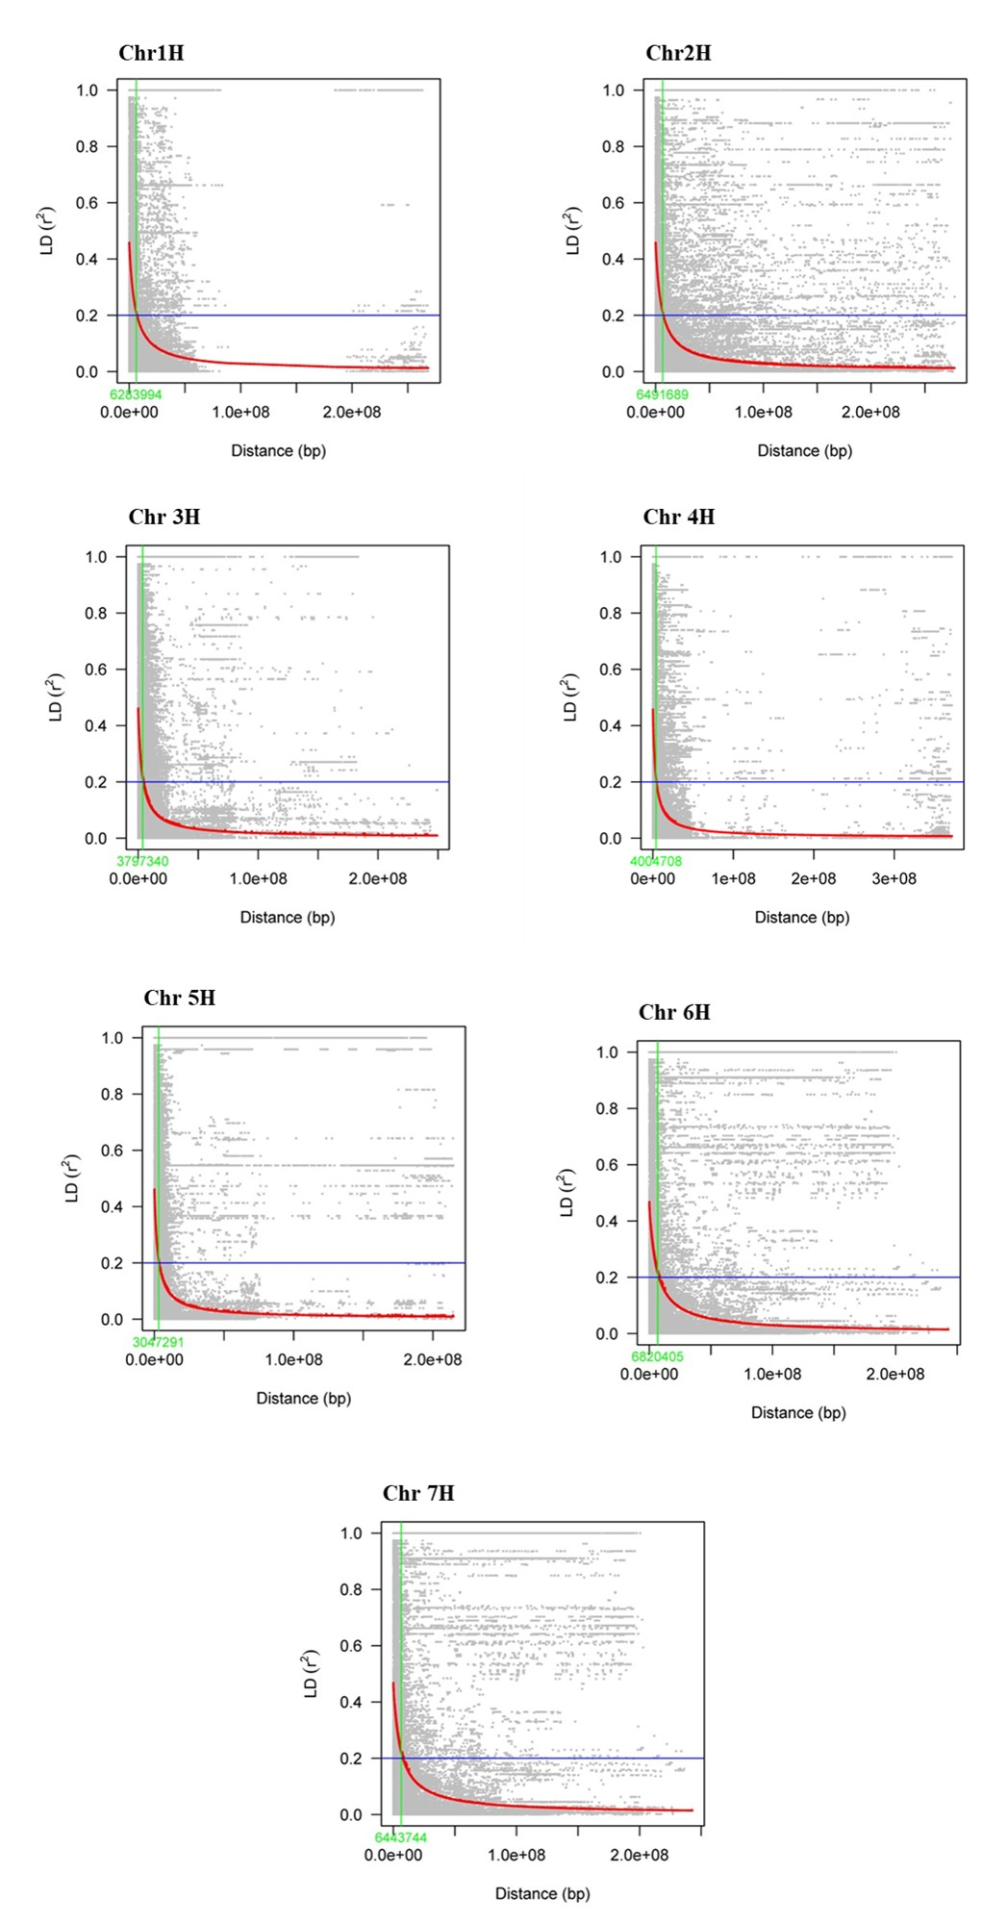
Supplementary Figure S2. Chromosome-wide LD decay plots fitted against the physical distance (i.e., base pairs) in six-row subpopulation. The blue horizontal line represents the half decay distance (r2). The red curved line represents the smooth regression model fitted to LD decay. The green vertical line represents the distance between the marker pairs which intersects the half decay and the LD decay curve.
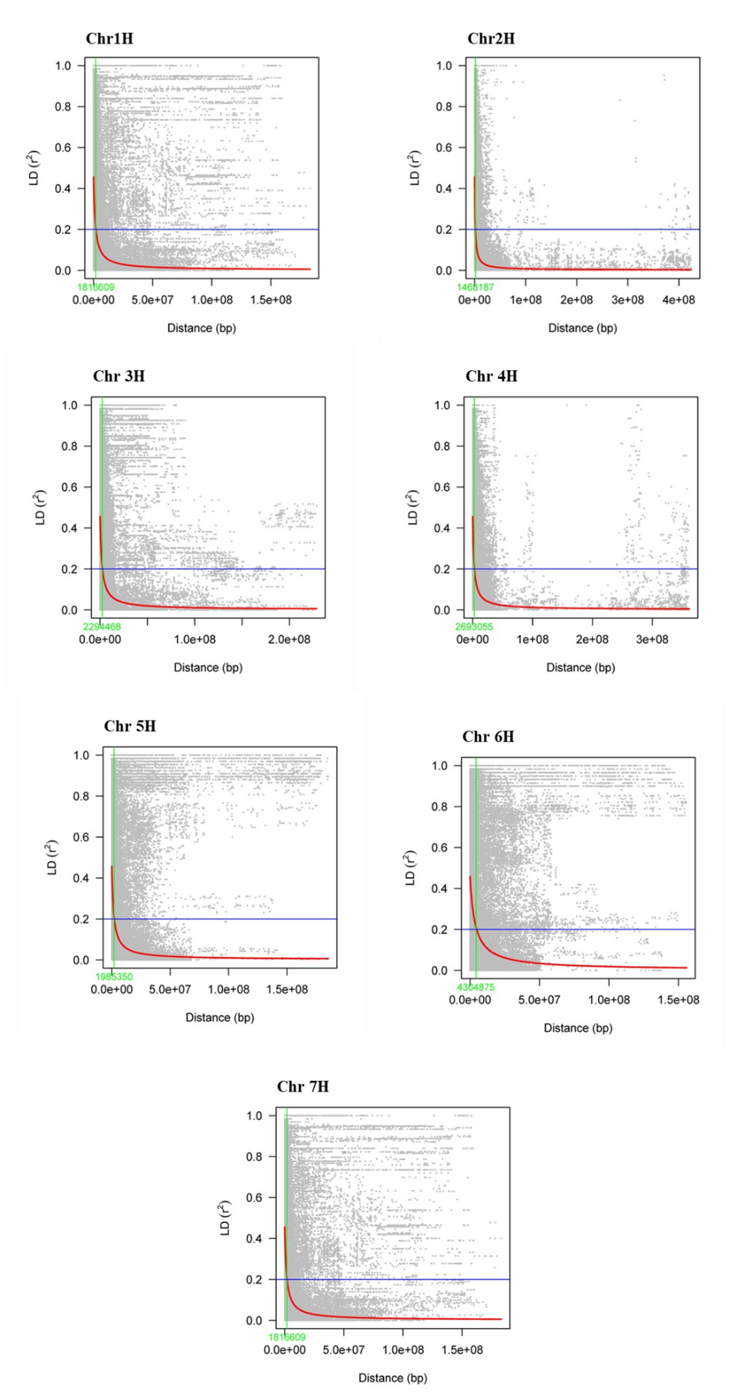
Supplementary Figure S3. Chromosome-wide LD decay plots fitted against the physical distance (i.e., base pairs) in genebank subpopulation. The blue horizontal line represents the half decay distance (r2). The red curved line represents the smooth regression model fitted to LD decay. The green vertical line represents the distance between the marker pairs which intersects the half decay and the LD decay curve.
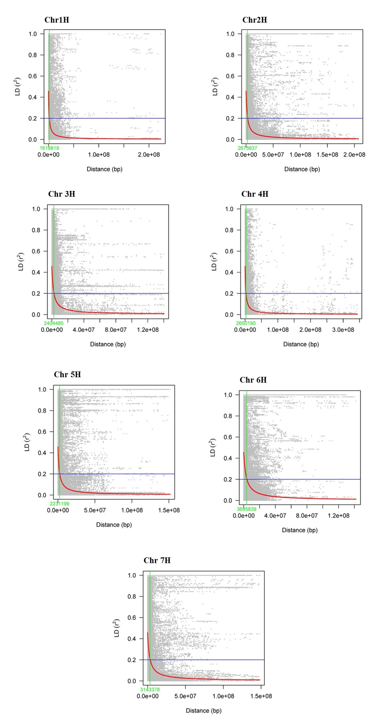
Supplementary Figure S4. Chromosome-wide LD decay plots fitted against the physical distance (i.e., base pairs) in 2R+6R (combination of two-row and six-row) subpopulation. The blue horizontal line represents the half decay distance (r2). The red curved line represents the smooth regression model fitted to LD decay. The green vertical line represents the distance between the marker pairs which intersects the half decay and the LD decay curve.

Supplementary Figure S5. Chromosome-wide LD decay plots fitted against the physical distance (i.e., base pairs) in 2R+genebank (combination of two-row and genebank) subpopulation. The blue horizontal line represents the half decay distance (r2). The red curved line represents the smooth regression model fitted to LD decay. The green vertical line represents the distance between the marker pairs which intersects the half decay and the LD decay curve.
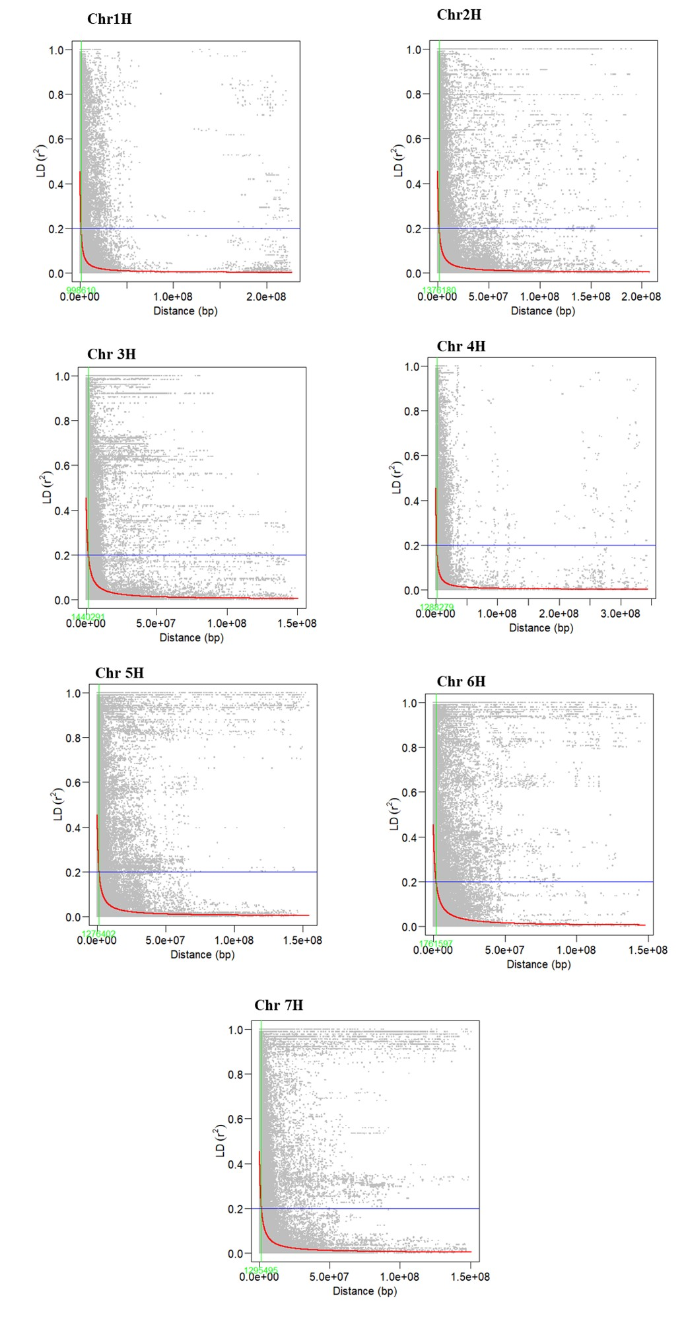
Supplementary Figure S6. Chromosome-wide LD decay plots fitted against the physical distance (i.e., base pairs) in 6R+genebank (combination of six-row and genebank) subpopulation. The blue horizontal line represents the half decay distance (r2). The red curved line represents the smooth regression model fitted to LD decay. The green vertical line represents the distance between the marker pairs which intersects the half decay and the LD decay curve.
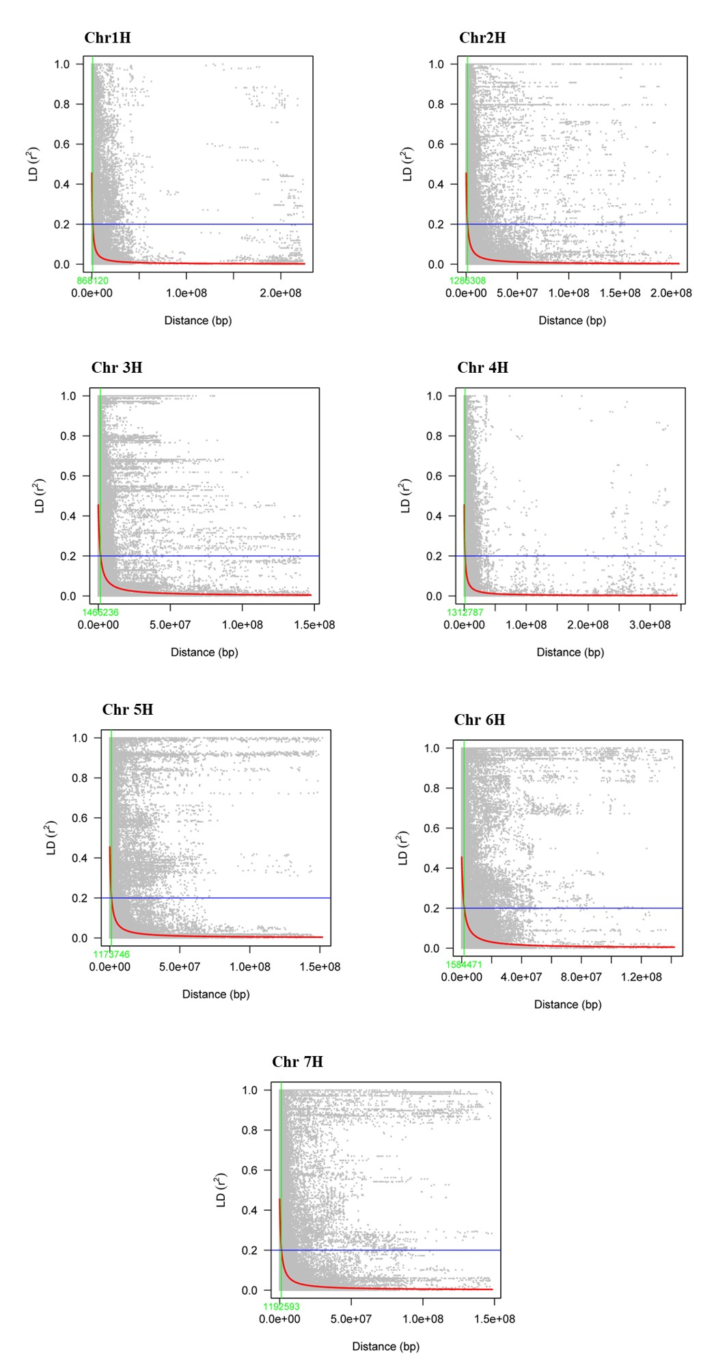
Supplementary Figure S7. Chromosome-wide LD decay plots fitted against the physical distance (i.e., base pairs) in 2R+6R+genebank (combination of two-row, six-row and genebank) subpopulation. The blue horizontal line represents the half decay distance (r2). The red curved line represents the smooth regression model fitted to LD decay. The green vertical line represents the distance between the marker pairs which intersects the half decay and the LD decay curve.
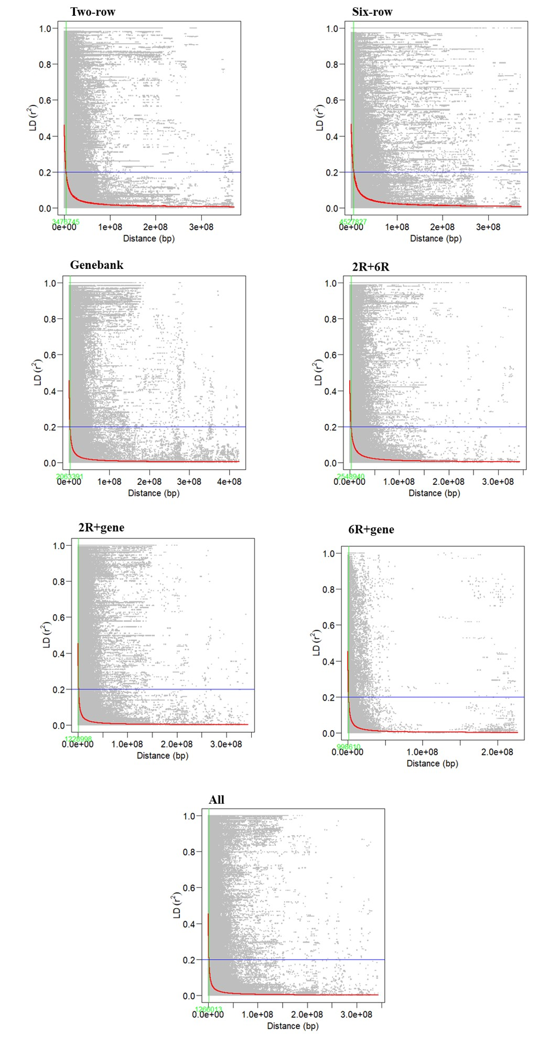
Supplementary Figure S8. Whole-genome LD decay plots for the tested single and combinations.

